**Brooklyn torah gazette**

**For parshas vayishlach 5783**

Volume 7, Issue 12 (Whole Number 319) 16 Kislev 5783/ December 10, 2022

**Printed L’illuy nishmas Nechama bas R’ Noach, a”h**

For a free subscription, please forward your request to [***keren18@juno.com***](mailto:keren18@juno.com)

Past stories can be found on the website **ShabbosStories.com**

**From Here to There**

**by Dennis Siegel**

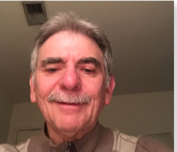

When I was a kid, my grandparents lived with us. We kept a kosher home for them, and I went to a Jewish school. I learned to read and write in Hebrew, and I studied Torah. Even when I was in college, I would say the Shema every night with a yarmulke on!

Thanks to this upbringing, reading Hebrew never left me – I also learned Yiddish from my grandparents.

Until recently, I was a Jewish believer in Christianity. I became a believer in 1984, under a Methodist minister. He moved away in 1994, and for the next 18 years I studied with a Christian friend, and listened to Christian radio. In 2012 and for the next nine years, I was part of a messianic congregation.

At that congregation I taught a class for Christians called “Sharing the Messiah with the Jewish people.”

Last year, a Jewish friend of mine started talking to me about the discrepancies in the Christian version of the Bible. At first, I didn’t want to hear it – but then I started digging around and searching. I read different books and watched different videos trying to understand the truth. (When I would be reading the Christian Bible, I noticed that some of the commentaries seemed anti-Semitic; but I ignored it completely.)

**Influenced by Rabbi Tovia Singer and Bentzion Kravitz**

 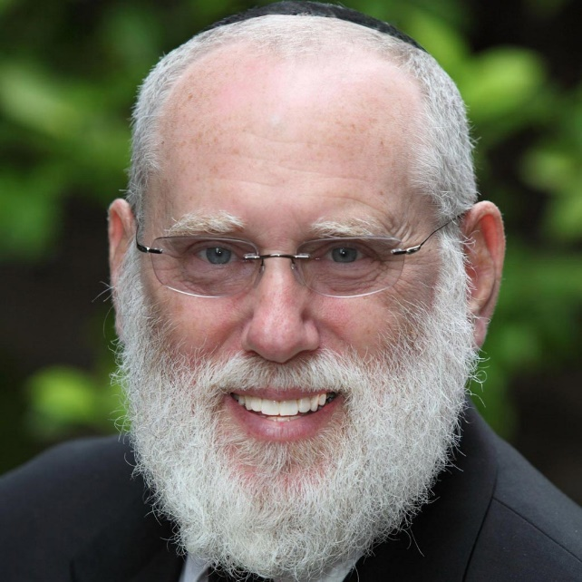

**From left to right: Rabbi Tovia Singer and Rabbi Bentzion Kravitz**

My friend told me what websites to go on for more information, so I began reading articles and watching videos by Rabbi Tovia Singer (Outreach Judaism) and Rabbi Bentzion Kravitz (Jews for Judaism). They showed me that G-d is not a man, but rather an all-powerful entity who created all things. This proved to me that my previous congregation was wrong in its beliefs. I would go on a Christian website and compare what I was learning to what was said in the Christian Bible. What I found was anything but the truth.

Finally, I came to the conclusion that my friend was right: Hashem is the only G-d of Abraham Isaac and Jacob.

I threw out all my bibles and erased that experience from my life. Being that I was so heavily involved with this congregation, it was a huge shock for me to find out the truth.

I met a rabbi from Chabad who gave me a prayerbook and mezuzos. He even purchased a pair of Tefilin for me which I put on every morning. I am a Levite and I now go to Chabad every Thursday and get called to the Torah.

**Trying to Correct the Christianity that He Taught His Son**

When my son was 8-years-old, I started teaching him about Christianity. He was a very devout Christian, and he studied his Bible daily. For over a year, I never told him about what I had found out. Recently, I took a walk with him and apologized to him for what I had taught him. I told him about my journey and how I had found the real truth about G-d, Christianity and the Bible.

He asked me lots of questions, and I was able to answer them. I showed him all the problems with Christianity, and I told him not to just believe me; rather, he should see it in the Torah.

He is now reading the Torah with Rashi on Chabad.org

I had been away for a long time, and at my friend’s recommendation I joined JNet and was set up with my partner David.

David is a very nice man with a wonderful family of good Jewish people. He has sent me some of his son’s (a rabbi) encouraging messages, and I have learned a lot from them and from David himself – he is an educated man! David answered a lot of questions that I had. I enjoy his company very much; he has a good sense of humor and I like getting to know him better. It has been a very good learning experience for me.

**Understanding More About Being Jewish**

I have learned a lot from David and his life experiences. He’s helping me understand more about being Jewish. Even when I was learning at the messianic congregation, there were times when I never really felt Jewish, I felt there was always something missing in my life, and I couldn’t figure out why; but now I know that it was because I was missing the proper understanding of who G-d is.

David has learned a lot about me and my background. We have a great relationship. I have learned so much from him about Moshiach and about what the world will be like when he comes. David has also helped me put my Tefilin on in the proper way.

One thing that I would like to tell all the JNet members; make sure that your partner is a proper match. See if the person that you are speaking with can help you as much as you help them. It’s a relationship that will grow but it needs to blossom in the beginning. JNet is a wonderful organization and I recommend it to everyone who wants to know more about the Torah way.

JNet – Jewish Learning Network, provides people the opportunity to study any area of Torah on any level in any language with a study partner. To become a JNet Study Partner call 347-770-JNet, or email info@jnet.org. A division of Merkos L’Inyonei Chinuch.

*Reprinted from the Parsha Vayeitzei 5783 edition of L’Chaim, a publication of the Lubavitch Youth Organization in Brooklyn, NY.*

**Rav Avigdor Miller on**

**Talking to Hashem**

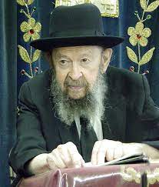

**QUESTION: How does one talk to Hashem?**

**ANSWER:** And this I’ll answer as follows. At first you have to be a hypocrite. You have to do it superficially; you have to say the words. And that’s what we do when we daven. We’re talking to Hashem although actually it’s קרוב אתה בפיהם ורחוק מכליותיהם. That’s what the Navi said: “You are close in their mouths but You are far away from their kidneys” – that means from their insides. And that’s the truth. That’s what davenen is; it’s superficial.

It’s only when a man sincerely embarks on a career of learning to speak to Hashem that his davenen becomes meaningful. After a while when he says אתה, “You,” he feels he’s talking to somebody. And when that great day comes, then you know you have arrived.

And so first do it superficially. You’re a hypocrite. Of course, it’s a good hypocrisy. You’re doing it to train yourself. You talk to Hashem whenever you can and you say, “I thank You Hashem that You have made me healthy.”

When you see a man hopping in the street with one empty trousers leg, and he has crutches; and you have two good legs – you don’t need any crutches – so you have to stop and say, “Boruch atah Hashem that I have two good legs.” You see a man walking in the street with one empty sleeve pinned to his pocket, then you have to thank Hakodosh Boruch Hu that your sleeves are not empty.

And little by little you’ll get accustomed to saying the words, and after a while you’re going to feel that there’s Somebody actually listening. That’s what the Mesillas Yesharim says, that at first you say it and after a while the realization enters your mind. Because you have an instinct that all human beings have that Hashem is actually there and He’s listening.

*Reprinted from the November 30, 2022 email of Toras Avigdor (Tape #317 – July 1980).*

**Thoughts that Count**

I have sojourned with Laban and lingered until now. And I have oxen, and donkeys and flocks, and men-servants and maidservants, and I have sent to tell my lord, that I may find favor in your eyes (Gen. 32:5-6)

Jacob thought that Esau might ask his messengers, "If Jacob is such a good brother, why hasn't he contacted me until now?" Jacob told them that they should reply that he "lingered until now" and didn't come to meet Esau earlier because he was an impoverished shepherd who worked for Laban, and he didn't want to distress his brother by revealing his indigent status. However, now that he was arriving with "oxen and donkeys, etc..." he is sure his brother Esau would be happy for him. *(Klei Chemda)*

*Reprinted from the Parshat Vayishlach 5758/1998 edition of L’Chaim. Adapted from Vedibarta Bam - by Rabbi Moshe Bogomilsky*

**The Importance of Donkeys**

The Hebrew word for "donkeys" is actually written in the singular form in this verse. Jacob's donkey is the same donkey upon which Moshiach will ride. He will arrive in a humble, modest way, overcoming the nations of the world quietly just as Jacob did to Esau. *(Bereishit Raba, Zacharia, Metzudot David)*

*Reprinted from the Parshat Vayishlach 5758/1998 edition of L’Chaim. Adapted from Vedibarta Bam - by Rabbi Moshe Bogomilsky*

**The Connection Between Parshat Vayishlach and**

**The 19th of Kislev**

**From the Talks of the Lubavitcher Rebbe**

**Rabbi Menachem Mendel Schneerson, Zt”l**

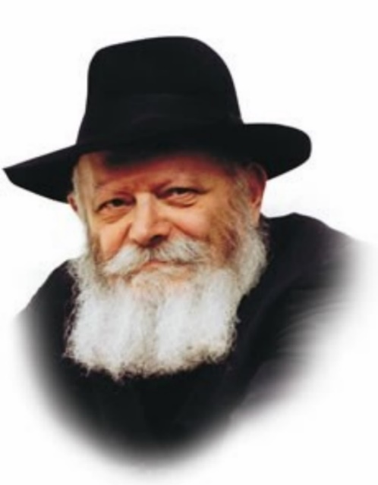

This week's Torah portion is Vayishlach. The 19th of the month of Kislev, which occurs this coming week, is the date on which Rabbi Shneur Zalman, the founder of Chabad Chasidut, was liberated from prison.

Known among Chasidim as the Festival of Liberation, it always falls out in close proximity to the week when Vayishlach is read. As "nothing happens by chance," we must conclude that the Festival of Liberation is alluded to in Vayishlach.

The main idea of the 19th of Kislev is spreading the wellsprings of Chasidut outward. The "wellsprings," the innermost part of Torah, must not remain at their source, but must flow "outward" and inundate even the lowest parts of the earth. Furthermore, not only must the waters of Chasidut be carried everywhere, but the wellsprings themselves must be conveyed to every single Jew, no matter where he/she is.

The 19th of Kislev teaches us the necessity of bringing the life- giving waters of Torah, and particularly the inner-part of Torah as expounded in Chasidut, to every Jew.

**The Meaning of the Name for the Portion**

The name of this week's portion, "Vayishlach," means "And he sent."

A shliach, an emissary (from the same root as vayishlach), is a person who is dispatched in the sender's stead; moreover, "a person's emissary is just like him." In other words, when an emissary is sent to a certain place to carry out his mission, it is the same as if the sender himself has made the journey.

This concept of "spreading the wellsprings outward" is expressed in the word "vayishlach," the name of our portion. The wellsprings must not stay at their source, but must be sent ever outward to reach as many people as possible.

The concept of Vayishlach exists in every age and in every generation.

G-d "sends" the soul down from the celestial spheres to be enclothed within a corporeal body, to enable the person to serve G-d within the context of the physical world. This shlichut (mission) began with Adam and Chava (Eve), and is continued by their descendants.

**Emissaries of the Many Torah Giants**

The phenomenon of sending emissaries has existed throughout the generations. We find that many Torah giants sent shluchim to carry out various holy missions.

The concept of shlichut was further emphasized by the Baal Shem Tov, founder of Chasidut and his spiritual "descendants," especially Rabbi Shneur Zalman and his successors; they, in turn, entrusted every Jew with the holy mission of "spreading the wellsprings outward."

In fact, the Previous Rebbe declared that shlichut is the unique mitzva of our generation. Every Jew must be a shliach to spread the wellsprings of Torah and Judaism wherever he or she goes. This is the unique role of our generation.

*Reprinted from the Parshat Vayishlach 5758/1998 edition of L’Chaim. Adapted from Likutei Sichot, Volume 25.*

**Rabbi Berel Wein on**

**Parshas Vayishlach 5783**

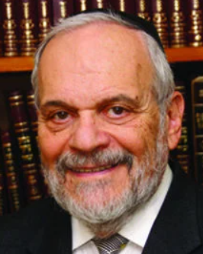

 The prophet of Israel, describing what can unfortunately be characterized as the usual situation in Jewish life, states that it is comparable to one who flees from the lion and finds one's self in the embrace of a bear. Our father Jacob, who barely escapes from the treachery of Lavan, soon finds himself confronted by the deadly mob of his brother Eisav.

Jacob, in his confrontation with Lavan, chooses the option of flight as he removes himself from the territory controlled by Lavan and his sons. But this option of flight is no longer possible in his contest with Eisav. Jacob is in his own land, the land of his ancestors, the land promised to him personally by God Himself, to be his rightful residence. As such, Jacob has nowhere to run.

As taught to us by Midrash and quoted by Rashi, his only options were to stand and fight, to buy Eisav off with monetary tribute, and/or to pray. The option of fleeing does not enter the equation in any fashion. This is perhaps the basis for the well-known Talmudic dictum severely limiting the right of a Jew to leave the Land of Israel cavalierly.

Polish Jewish history, from biblical times to the present, shows us that exile from the Land of Israel on a collective basis never occurred voluntarily. The most mobile, wandering people in the history of civilization never left their homeland of their own volition. In this they were following the example of their father Jacob, who never considered fleeing from the Land of Israel in order to avoid the long expected and dreaded confrontation with his aggressive and volatile brother.

In our long and winding road of exile, over the past two millennia, when one country closed down for us because of economic, social or religious reasons, the Jewish people moved on elsewhere. But as we have discovered, we have run out of places to go in the world. There are no new undiscovered continents on the face of the globe, no seemingly safe havens left for escape.

This is part of the reason for the establishment of the State of Israel and its phenomenal growth and inexplicable stability. Even though it has been provoked by errors of policy and with concessions to its neighbors, it is as though the Jewish people, like their ancestor Jacob, declared that this is where they will make their stand.

Prayer is a constant in current Israeli life, even for those who do not deem themselves to be observant of Jewish law and tradition. But in spite of all of the troubles, problems, and the myriad challenges that living in our country poses, flight in a collective sense is a nonexistent possibility.

Unable to defeat us militarily or economically, even though diplomatically they have wounded us severely, our enemies openly declare their intent to make us leave our homeland. But that is a very unrealistic policy. The children of Jacob, in the state that bears his name, certainly will follow his example until it finally brings quieter times and better relations.

Shabbat Shalom

*Reprinted from this week’s website of rabbiwein.com*

**The Chida**

**By Rabbi Nissan Mindel**

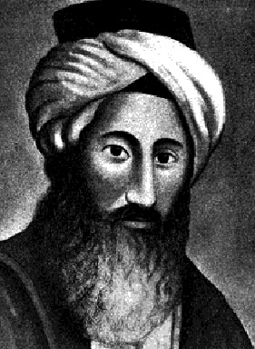

The Chida (1724-1807) Rabbi Chaim Joseph David Azulai was born in Jerusalem, to a Sephardic family who had been living in the holy city for centuries. The family had given us great Talmudists and Cabbalists. The most famous of ChIDA's ancestors was Rabbi Abraham Azulai, who wrote a commentary on the sacred book of Cabbala, the Zohar. He died in Hebron, nearly two hundred years before ChIDA was born.

The ChIDA's father, Rabbi Yitzchak Zerachiah Azulai, was also a very learned man. He was the boy's first teacher. Later on, the boy studied the Talmud and the inner wisdom of the Torah under the guidance of Rabbi Joseph Nabbon, Rabbi Isaac HaKohen Rapaport, and Rabbi Chaim ben Attar. The latter was a great Cabbalist, and he came to Jerusalem when ChIDA was still quite young.

The ChIDA was blessed with an excellent memory, and he became famous at an early age. At the age of sixteen, he wrote his first book, entitled "Haalem Davar" ("Some Oversights"). In it he pointed out many errors in connection with the versions and editions of many works known in his time. This work was never published.

A year later, he wrote his first Talmudic commentary, "Shaar Yosef" ("The Gate of Joseph") on the tractate "Horayoth In 1753, when only twenty-nine years old, Rabbi Chaim Joseph David Azulai was appointed as an emissary to represent the Holy Land abroad. It was a very old custom to send a representative of the Holy Land to visit Jewish communities elsewhere.

**Collecting Funds for the Holy**

**Institutions in the Land of Israel**

One reason for it was to collect funds in support of the holy institutions of learning in the land of Israel. Another reason was to keep alive interest in the Holy Land. Jews in all countries looked forward to the arrival of the "Meshulach" (emissary) from the Holy Land, for he was usually a man of great learning and piety, and he would inspire them with love for everything that was dear to the Jewish heart. It was therefore a great distinction to represent the Jewish community of the Land of Israel.

The ChIDA spent five years on his mission, visiting Egypt, Italy, Germany, Holland, England, France, Sicily, Rhodes, Turkey and Syria. Everywhere, he was welcomed with great respect and veneration. Being a great lover of books and learning, this trip was a great opportunity for Rabbi Chaim Joseph David Azulai. He spent all available time in the libraries of the cities he visited, studying ancient manuscripts and books.

On his return, he spent six years in study and research in his native Jerusalem. Then he was called again to undertake a mission to the Sultan of Turkey, where the Jews suffered great hardships. The ChIDA was successful in improving the position of the Jews of Turkey, for he greatly impressed the Sultan and his government.

**Served as Rabbi in Cairo, Egypt**

After he completed this mission he received a call to become the Rabbi of the important Jewish community in Cairo, Egypt. He held this post for five years. During this time, he unearthed many "Genizoth" (buried treasures of ancient manuscripts) and further added to his vast knowledge of books and authors.

Later he returned to the Holy Land and devoted himself to the further study of the inner wisdom of the Torah and mysteries of G-d's creation (Cabbalah). After three years of intensive study, the ChIDA was once again called to leave the Holy Land on a visit to the Jewish communities of North Africa and Europe on behalf of the Yeshivoth and other institutions in the Holy Land.

Although he knew how wearisome such travels would be from his past experience, his love for his people and his desire to discover new treasures of Hebrew literature made him accept the urgent request. Again, the ChIDA rummaged through dusty museums, libraries and private collections in search of centuries-old treasures of wisdom.

Only a man like the ChIDA, whose love for books was so great, could have the patience to devote all his spare time to this kind of work. Thus, for instance, he was grateful for the opportunity to visit Paris not for its beautiful boulevards and curiosities, but for the five thousand manuscripts he discovered in the Louvre and other collections. The ChIDA's beautiful features and majestic bearing made a deep impression on everyone, Jew and non-Jew alike. He was regarded as a saintly man, whose prayers were acceptable On High and whose blessing was therefore very desirable.

**Deeply Impressed King Louis XVI of France**

Many a diplomatic mission took him to the courts and castles of kings and princes. When he visited King Louis XVI of France in the beautiful castle of Versailles, and before he had a chance to introduce himself, the king was obviously so greatly impressed that he asked what country's ambassador this visitor was. The king, one of the most powerful rulers in Europe, had never seen a more-stately and impressive looking ambassador!

This and many other incidents we learn from the ChIDA's diary, which was later published under the name "Maagal Tov," (the Good Circle). In it, the author records his observations and experiences in the course of his travels. They give us an insight into the political, economic, and religious life of those days. Rabbi Azulal became known as a great authority on books and manuscripts. His wonderful memory helped him to acquire a vast store of knowledge and facts.

He used to buy all the books he could afford, but he could not afford to buy many. However, throughout his travels he gathered material, made notes, and planned his writings. Finally, in the year 1778, Rabbi Chaim Joseph David Azulai settled in the quiet and prosperous Jewish community of Livorno (Leghorn), Italy, to begin writing his major works. Livorno was then a center of Hebrew printing.

**Published “Shem Hagedolim” (“Name of the Great”)**

The ChIDA found there all the necessary facilities for publishing his works, and generous book lovers who helped him do it. A certain physician, Michael Pereira de Leon, a descendant of one of the oldest Jewish families in Italy, enabled ChIDA to devote all his time to his writings, taking care of all his financial needs.

The ChIDA's major work of this period was his classic dictionary of Hebrew Literature, called "Shem Hagedolim" (Name of the Great). The book contains the names and short data of some 1500 scholars and authors. The second part, entitled "Vaad Lachachamim" (Assembly for the Wise) gives the names of some 2000 works, published and unpublished, and describes their contents. Many of the books mentioned had never been heard of, and important facts about authors and books would have been lost to us but for this great work of ChIDA. It was later revised and supplemented by various scholars at different times.

The "Shem Hagedolim" has become one of the most important and invaluable source books of Jewish literature and Jewish history. The ChIDA edited many important manuscripts, such as the "Seder Tanaim Vaamoraim" (History of the Teachers of the Talmud), dating back to the period of the Geonim; a digest of the Responsa (questions and decisions of Jewish law) of the ROSH (Rabbenu Asher ben Jechiel); a Biblical commentary by Rabbi Isaiah di Trani the Elder, etc.

**Died at the Ripe Old Age of 83**

Forty of the ChIDA's seventy-one works were published. Among them are commentaries on tractates of the Talmud and on the four volumes of the Shulchan Aruch, responsa, sermons, Biblical commentaries, etc. Many of his writings on Cabbalah and prayers were not published. Rabbi Chaim Joseph David Azulai died at the ripe old age of 83, in Leghorn, Italy. His memory continued to live in the hearts of his people. Many Jews used to make pilgrimages to his grave or send letters to be deposited there, praying that the saintly Rabbi be an intercessor for them in the Heavenly Court. (Rabbi Nissan Mindel- Kehot Publication Society)

*Reprinted from the Parshat Vayishlach 5783 email of R’ Yedidye Hirtenfeld’s whY I Matter parsha sheet for the Young Israel of Midwood in Brooklyn, NY.*

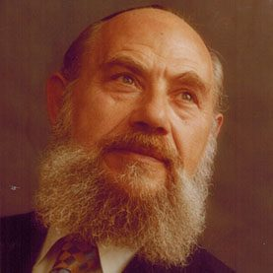

**Rabbi Nissan Mindel**

Rabbi Nissan Mindal was born in Riga, Latvia in March, 1912, one of nine children, to Yaakov Yitzchak and Bunia Mindel. He left Riga for America by way of Sweden together with the sixth Lubavitcher Rebbe, Rabbi Yosef Yitzchak Schneersohn and his entourage, arriving at New York in March 1940, and settled at Long Beach where he was one of the founders of the Young Israel of Long Beach.He died in Crown Heights, Brooklyn in 1999. Mindel served on the staff of the Lubavitcher Rebbe, Rabbi Menachem Mendel Schneerson. Nissan Mindel recorded a great deal of Chabad history and helped edit the memoirs of the sixth Lubavitcher Rebbe, Rabbi Yosef Yitzchak.

**Reburial of the Chida**

In 1956[]](https://en.wikipedia.org/wiki/Chaim_Yosef_David_Azulai#cite_note-6), the 150th anniversary of the Chida's death, Israel's Chief Rabbi [Yitzhak Nissim](https://en.wikipedia.org/wiki/Yitzhak_Nissim) began work on a planto reinter the Chida in Israel. This included getting the approval and cooperation of the [Leghorn](https://en.wikipedia.org/wiki/Livorno) Jewish community, acquiring a special 600 square meter plot on [Har Hamenuchot](https://en.wikipedia.org/wiki/Har_Hamenuchot), and constructing an [ohel](https://en.wikipedia.org/wiki/Ohel_(grave)" \o "Ohel (grave)) over the grave. On Tuesday, 20 Iyar 5720 (17 May 1960), 154 years after his [Petira](https://en.wikipedia.org/wiki/Petira" \o "Petira), the Chida's final written wish, to return to Israel, "came true." Reprinted from Wikopedia.

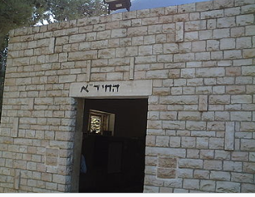

**The burial place of the Chida in Har Hamenuchos in Jerusalem**

**More Thoughts for the Parsha**

Lest he come and strike me down, mother and children (Gen. 32:12)

The word "mother" in this verse is singular, even though Jacob has four wives. Many people assumed that since Laban had two daughters and his sister Rebecca had two sons, the sons would marry the daughters; Esau, being the eldest, would marry the eldest sister Leah. For many years Leah cried and pleaded to G-d that she not be forced to marry the wicked Esau, and G-d accepted her plea. Jacob was worried that Esau would hold a particular grudge against Leah for not wanting to marry him and would smite her. Thus, he did not want to emphasize that he had more than one wife.

*(Be'er Mayim Chayim)*

And he took from what came to his hand...a present for Esau his brother (Gen. 32:14)

The words "what came to his hand" seem unnecessary. When Jacob began to prepare the animals as gifts for his brother, the animals were reluctant to be given to Esau, an idol-worshipper. Jacob had to take them with his hand and persuade them to go.

*(Beit Yakov)*

*Reprinted from the Parshat Vayishlach 5758/1998 edition of L’Chaim. Adapted from Vedibarta Bam - by Rabbi Moshe Bogomilsky*

***Getting Ready for Chanukah 5783***

